**Deploying ASP.NET application in Windows Server using IIS**

1. Create a AWS EC2 Instance with AMI of Windows Server 2019 Base and Select Appropriate Key Pair
2. Create Security group to enable SSH and RDP or Simply open all ports 0 – 65535 by clicking All-TCP.
3. Once Instance is created click on connect🡪then get password 🡪 Upload the Key which you selected while creating instance 🡪Decryt Password then it looks as below

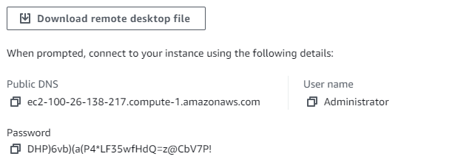

1. Download remote desktop file and copy password
2. Connect using downloaded file and password
3. In Your System or Windows Server download Windows Web deploy <https://www.microsoft.com/en-us/download/details.aspx?id=43717>
4. Copy downloaded file to Windows Server and Install using “Complete Type”
5. In Windows Server go to **Server Manager**
6. First time we will se “configure this local server”
7. 🡪 Click on Add role and feature 🡪 Next 🡪 Next 🡪 make sure first radio button is clicked “server from server pool” 🡪 Next 🡪
8. Select “Web Server IIS” 🡪 Next 🡪 Add feature 🡪 Next
9. Make Sure .NET Framework is Check 🡪 Next 🡪Next 🡪
10. Here [IMP] Make sure to check “Basic Authentication” in Security, Application Developement, In Application Development Select 🡪 Net Extensibilty 4.7 and ASP.NET 4.7 and then Management Services in Management tool. **Then Click Next and Install.**
11. Once Install Click on Close.
12. **Restart or Reboot this Instance**
13. Run inetmgr in run command or directly open IIS to see properly installed or not.
14. In IIS 🡪 Click on machine name and in middle you will find management service click and make sure “enable remote connection” is checked

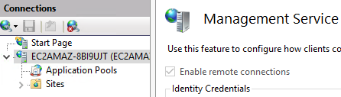

1. Now Same, go to machine name and enable basic authentication.

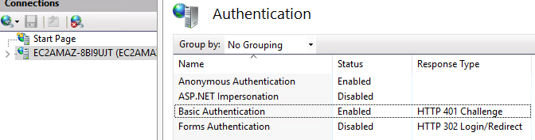

1. Delete the default page and add new website as below, make sure physical path is in **“inetpub\wwwroot”**

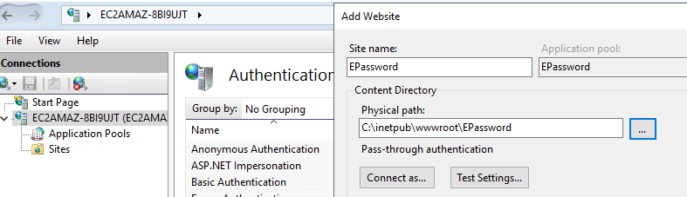

1. Now to deploy the files in the directory folder. Follow as below, Once clicked on Setup you will see publish file in desktop.

|  |  |
| --- | --- |
|  |  |

Till here it was full of setup, Now we can Deploy Your application

1. Copy the publised file from server to your machine
2. Go to visual studio, right click on project and click on “Publish” 🡪 Add publish profile.
3. Click on Import profile and select the file which you copied above (Step 1)
4. Once Imported It looks something like this.

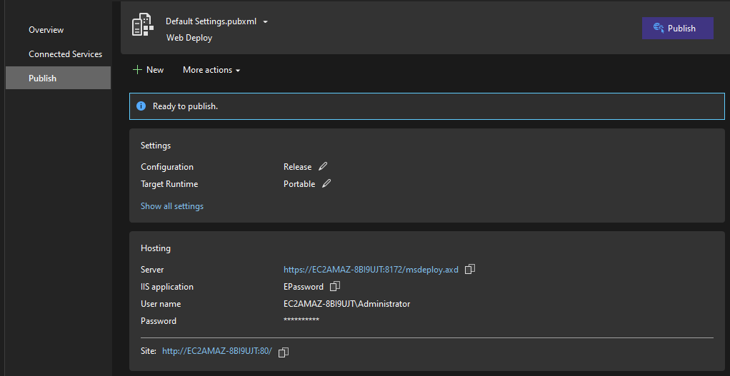

1. Now we need to perform small changes in the imported profile i.e. Replace EC2_Name with its Public IP and also in place of password give the password which you got in AWS after decrypting

Refer step Initial 3, Once validated click 🡪 Next 🡪 Save



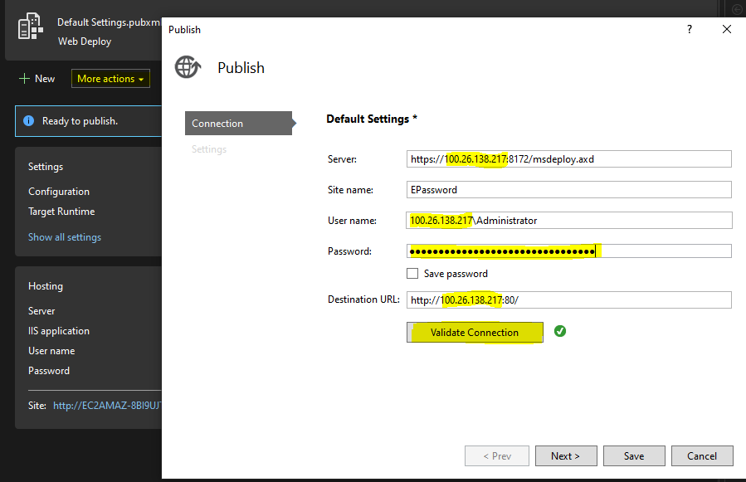

1. Click on Publish Button and first time it will ask for password give password above specified and browse url
2. [NOTE] – Make Sure to replace the public IP incase you are stopping and restarting the instance in the above imported profile.